Name: Vaishnavi Jitendra Salunkhe.
Roll No: 38
Lab Exercise:01
Title: Implement rational number as new data type.
Code:
#include<stdio.h>
#include<conio.h>
struct Rational {
int num;
int den;
};
int main() {
struct Rational r1,r2,sum;
int res;
clrscr();
printf("Enter numerator and denominator for first rational number:");
scanf("%d%d",&r1.num,&r1.den);
printf("Enter numerator and denominator for second rational number:");
scanf("%d%d",&r2.num,&r2.den);
//Addition formula:(a/b)+(c/d)=(ad+bc)/bd
sum.num=r1.num*r2.den+r2.num*r1.den;
sum.den=r1.den*r2.den;
res=sum.num/sum.den;
printf("%d%d+%d%d",r1.num,r1.den,r1.den,r2.num,r2.den);
printf("\n sum=%d",res);
getch();
}
Output:
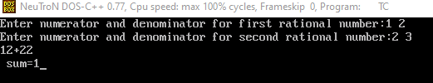

Name: : Vaishnavi Jitendra Salunkhe.
Roll No:38
Lab Exercise:02
Title:Implement complex number as new data type.
Code:
#include<stdio.h>
#include<conio.h>
struct Complex {
float real;
float imag;
};
int main() {
struct Complex c1,c2,sum;
clrscr();
printf("Enter real and imaginary part of first complex number:");
scanf("%f%f",&c1.real,&c1.imag);
printf("Enter real and imaginary part of second complex number:");
scanf("%f%f",&c2.real,&c2.imag);
sum.real=c1.real+c2.real;
sum.imag=c1.imag+c2.imag;
printf("sum=%2f+%2i\n",sum.real,sum.imag);
getch();
}
Output:
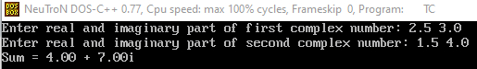

Name: Vaishnavi Jitendra Salunkhe.
Roll No: 38
Lab Exercise:03
Title: Write your own function for string operations.
Code:
#include<stdio.h>
#include<conio.h>

struct matrix {
int row;
int col;
int data[10][10];
};

void main() {
struct matrix m1, m2, sum;
int i, j;
clrscr();
printf("Enter rows and columns: ");
scanf("%d %d", &m1.row, &m1.col);
m2.row = sum.row = m1.row;
m2.col = sum.col = m1.col;
printf("Enter elements of first matrix:\n");
for(i = 0; i < m1.row; i++) {
for(j = 0; j < m1.col; j++) {
scanf("%d", &m1.data[i][j]);
}
}
printf("Enter elements of second matrix:\n");
for(i = 0; i < m2.row; i++) {
for(j = 0; j < m2.col; j++) {
scanf("%d", &m2.data[i][j]);
}
}
for(i = 0; i < sum.row; i++) {
for(j = 0; j < sum.col; j++) {
sum.data[i][j] = m1.data[i][j] + m2.data[i][j];
}
}
printf("Sum of matrices:\n");
for(i = 0; i < sum.row; i++) {
for(j = 0; j < sum.col; j++) {
printf("%d ", sum.data[i][j]);
}
printf("\n");
}
getch();
}
Output:

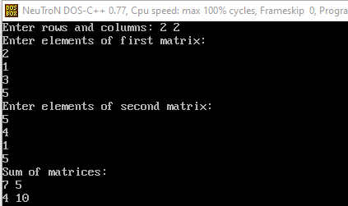

Name: Vaishnavi Jitendra Salunkhe.
Roll No: 38
Lab Exercise:04
Title: Implement matrix as new data type.
Code:
#include<stdio.h>
int strlength(char str[]);
void strcopy(char s1[],char s2[]);
void strconcat(char s1[],char s2[]);
int strcompare(char s1[], char s2[]);
void strreverse(char str[]);
int main()
{
char str1[100],str2[100];
int choice,result;
while(1)
{
printf("\n String Operation Menu\n");
printf("1.Length\n");
printf("2.Copy\n");
printf("3.Concatenate\n");
printf("4.Compare\n");
printf("5.Reverse\n");
printf("6.Exit\n");
printf("Enter your choice:");
scanf("%d",&choice);
switch(choice)
{
case 1:
printf("Enter string:");
scanf("%s",str1);
printf("Length=%d\n",strlength(str1));
break;
case 2:
printf("Enter source string:");
scanf("%s",str1);
strcopy(str2,str1);
printf("Copied string:%s\n",str2);
break;
case 3:
printf("Enter first string:");
scanf("%s",str1);
printf("Enter second string:");
scanf("%s",str2);
strconcat(str1,str2);
printf("Concatenated string:%s\n",str1);
break;
case 4:
printf("Enter first string:");
scanf("%s",str1);
printf("Enter second string:");
scanf("%s",str2);
result=strcompare(str1,str2);
if(result==0)
printf("String are equal\n");
else
printf("Strings are not equal\n");
break;
case 5:
printf("Enter string:");
scanf("%s",str1);
strreverse(str1);
printf("Reversed string:%s\n",str1);
break;
case 6:
return 0;
default:
printf("Invalide choice\n");
}
}
}
int strlength(char str[])
{
int i=0;
while(str[i]!='\0')
i++;
return i;
}
void strcopy(char s1[],char s2[])
{
int i=0;
while(s2[i]!='\0')
{
s1[i]=s2[i];
i++;
}
s1[i]='\0';
}
void strconcat(char s1[],char s2[])
{
int i=0,j=0;
while(s1[i]!='\0')
i++;
while(s2[j]!='\0')
{
s1[i]=s2[j];
i++;
j++;
}
s1[i]='\0';
}
int strcompare(char s1[],char s2[])
{
int i=0;
while(s1[i]==s2[i])
{
if(s1[i]=='\0')
return 0;
i++;
}
return 1;
}
void strreverse(char str[])
{
int i,j;
char temp;
i=0;
j=strlength(str)-1;
while(i<j)
{
temp=str[i];
str[i]=str[j];
str[j]=temp;
i++;
j--;
}
Output:
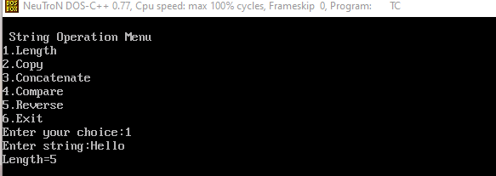

Name:Vaishnavi Jitendra Salunkhe.
Roll No: 38
Lab Exercise:05

Title: Implement stack using array.
#include<stdio.h>
# include <conio.h>
int stack[100],choice,n,top,x,i;
void push(void);
void pop(void);
void display(void);
int main()
{
clrscr();
top=-1;
printf("\n Enter the size of STACK[MAX=100]:");
scanf("%d",&n);
printf("\n\t STACK OPERATIONS USING ARRAY");
printf("\n\t--------------------------------");
printf("\n\t 1.PUSH\n\t 2.POP\n\t 3.DISPLAY\n\t 4.EXIT");
do
{
printf("\n Enter the Choice:");
scanf("%d",&choice);
switch(choice)
{
case 1:
{
push();
break;
}
case 2:
{
pop();
break;
}
case 3:
{
display();
break;
}
case 4:
{
printf("\n\t EXIT POINT ");
break;
}
default:
{
printf ("\n\t Please Enter a Valid Choice(1/2/3/4)");
}

}
}
while(choice!=4);
return 0;
}
void push()
{
if(top>=n-1)
{
printf("\n\tSTACK is over flow");

}
else
{
printf(" Enter a value to be pushed:");
scanf("%d",&x);
top++;
stack[top]=x;
}
}
void pop()
{
if(top<=-1)
{
printf("\n\t Stack is under flow");
}
else
{
printf("\n\t The popped elements is %d",stack[top]);
top--;
}
}
void display()
{
if(top>=0)
{
printf("\n The elements in STACK \n");
for(i=top; i>=0; i--)
printf("\n%d",stack[i]);
printf("\n Press Next Choice");
}
else
{
printf("\n The STACK is empty");
}

}
Output:

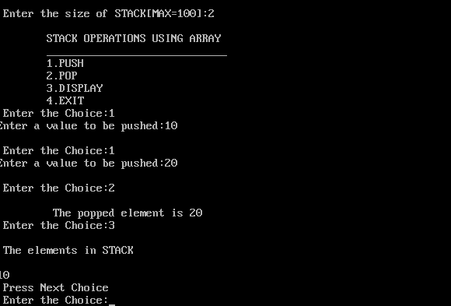

Name:Vaishnavi Jitendra Salunkhe.
Roll No: 38
Lab Exercise:06
Title: Implement stack using linked list.
Code:
#include <stdio.h>
#include <stdlib.h>
struct node {
int data;
struct node *next;
};
struct node *top = NULL;
void push(int value) {
struct node *newnode;
newnode = (struct node *)malloc(sizeof(struct node));
if (newnode == NULL) {
printf("Stack Overflow\n");
}
else {
newnode->data = value;
newnode->next = top;
top = newnode;
printf("Inserted: %d\n", value);
}
}
void pop() {
if (top == NULL) {
printf("Stack Underflow\n");
}
else {
struct node *temp = top;
printf("Deleted: %d\n", temp->data);
top = top->next;
free(temp);
}
}

void display() {
struct node *temp = top;

if (temp == NULL) {
printf("Stack is Empty\n");
}
else {
printf("Stack elements:\n");

while (temp != NULL) {
printf("%d\n", temp->data);
temp = temp->next;
}
}
}
void peek() {
if (top == NULL) {
printf("Stack is Empty\n");
}
else {
printf("Top element: %d\n", top->data);
}
}
int main() {
int choice, value;

while (1) {
printf("\n1.Push 2.Pop 3.Display 4.Peek 5.Exit\n");
printf("Enter choice: ");
scanf("%d", &choice);

switch (choice) {

case 1:
printf("Enter value: ");
scanf("%d", &value);

push(value);
break;

case 2:
pop();
break;

case 3:
display();
break;

case 4:
peek();
break;

case 5:
return 0;

default:
printf("Invalid choice\n");
}
}
}

Output:
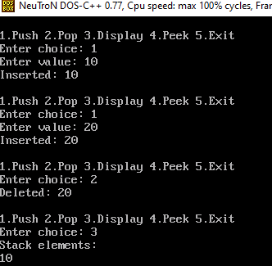



Name: Vaishnavi Jitendra Salunkhe.
Roll No: 38
Lab Exercise:07

Title: Use of stack for checking brackets in mathematical expression.
Code:
#include <stdio.h>
#include <string.h>
# include<conio.h>
# include <conio.h>
#define MAX 100

char stack[MAX];
int top = -1;

void push(char ch)
{
stack[++top] = ch;
}

char pop()
{
return stack[top--];
}

int isMatchingPair(char open, char close)
{
if(open == '(' && close == ')') return 1;
if(open == '{' && close == '}') return 1;
if(open == '[' && close == ']') return 1;
return 0;
}

int main()
{
char exp[100];
int i;

printf("Enter expression: ");
scanf("%s", exp);

for(i = 0; exp[i] != '\0'; i++)
{
if(exp[i] == '(' || exp[i] == '{' || exp[i] == '[')
push(exp[i]);

else if(exp[i] == ')' || exp[i] == '}' || exp[i] == ']')
{
if(top == -1 || !isMatchingPair(pop(), exp[i]))
{
printf("Not Balanced\n");
return 0;
}
}
}

if(top == -1)
printf("Balanced\n");
else
printf("Not Balanced\n");

getch();
}

Output:
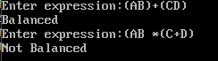

Name: Vaishnavi Jitendra Salunkhe.
Roll No: 38
Lab Exercise:08

Title: Conversion of infix to postfix expression.
Code:
#include <stdio.h>
#include <ctype.h>
#include <string.h>
#include <conio.h>
#define MAX 100
// Infix to postfix
char stack[MAX];
int top = -1;
void push(char ch)
{
stack[++top] = ch;
}
char pop()
{
return stack[top--];
}

int precedence(char op)
{
if(op == '+' || op == '-') return 1;
if(op == '*' || op == '/') return 2;
if(op == '^') return 3;
return 0;
}

int main()
{
char infix[100], postfix[100];
int i, j = 0;

printf("Enter infix expression: ");
scanf("%s", infix);

for(i = 0; infix[i] != '\0'; i++)
{
if(isalnum(infix[i]))
postfix[j++] = infix[i];

else if(infix[i] == '(')
push(infix[i]);

else if(infix[i] == ')')
{
while(stack[top] != '(')
postfix[j++] = pop();
pop();
}

else
{
while(top != -1 && precedence(stack[top]) >= precedence(infix[i]))
postfix[j++] = pop();
push(infix[i]);
}
}

while(top != -1)
postfix[j++] = pop();

postfix[j] = '\0';
printf("Postfix Expression: %s\n", postfix);
getch();
}

Output:
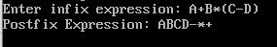

Name:Vaishnavi Jitendra Salunkhe.
Roll No: 38
Lab Exercise:09

Title: Evaluation of postfix expression.
#include <stdio.h>
#include <ctype.h>

#define MAX 100

// Expression evaluation using stack
int stack[MAX];
int top = -1;

// Push
void push(int val) {
if (top == MAX - 1) {
printf("Stack Overflow\n");
return;
}
stack[++top] = val;
}

// Pop
int pop() {
if (top == -1) {
printf("Stack Underflow\n");
return -1;
}
return stack[top--];
}

int main() {
char exp[100];
int i, op1, op2, result;

printf("Enter postfix expression: ");
scanf("%s", exp);

for (i = 0; exp[i] != '\0'; i++) {

// If operand (digit)
if (isdigit(exp[i])) {
push(exp[i] - '0'); // convert char to int
}
else {
op2 = pop();
op1 = pop();

switch (exp[i]) {
case '+':
result = op1 + op2;
break;
case '-':
result = op1 - op2;
break;
case '*':
result = op1 * op2;
break;
case '/':
result = op1 / op2;
break;
default:
printf("Invalid operator\n");
return 1;
}

push(result);
}
}

printf("Result = %d\n", pop());

return 0;
}

Output: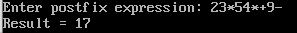

Name: Vaishnavi Jitendra Salunkhe.
Roll No: 38
Lab Exercise:10

Title: Implementation of queue using array.
Code:
#include <stdio.h>
# include <conio.h>
#define MAX 5

// Queue Implementation using array
int queue[MAX];
int front = -1, rear = -1;

// Enqueue
void enqueue() {
int value;
if (rear == MAX - 1) {
printf("Queue Overflow\n");
} else {
printf("Enter value: ");
scanf("%d", &value);

if (front == -1)
front = 0;

queue[++rear] = value;
printf("Inserted: %d\n", value);
}
}

// Dequeue
void dequeue() {
if (front == -1 || front > rear) {
printf("Queue Underflow\n");
} else {
printf("Deleted: %d\n", queue[front]);
front++;
}
}

// Display
void display() {
if (front == -1 || front > rear) {
printf("Queue is empty\n");
} else {
int i;
printf("Queue elements: ");
for ( i = front; i <= rear; i++) {
printf("%d ", queue[i]);
}
printf("\n");
}
}

// Main function with switch
int main() {
int choice;

do {
printf("\n--- Queue Menu ---\n");
printf("1. Enqueue\n");
printf("2. Dequeue\n");
printf("3. Display\n");
printf("4. Exit\n");

printf("Enter your choice: ");
scanf("%d", &choice);

switch (choice) {
case 1:
enqueue();
break;

case 2:
dequeue();
break;

case 3:
display();
break;

case 4:
printf("Exiting...\n");
break;

default:
printf("Invalid choice\n");
}

} while (choice != 4);

return 0;
}

Output:
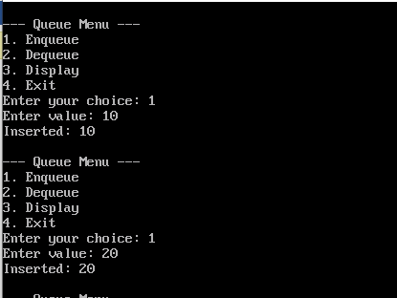
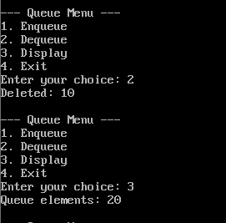

Name: Vaishnavi Jitendra Salunkhe.
Roll No: 38
Lab Exercise:11

Title: Implementation of queue using linked list.
#include <stdio.h>
#include <stdlib.h>

// Queue using Linked List
struct node {
int data;
struct node *next;
};

struct node *front = NULL, *rear = NULL;

// Enqueue
void enqueue() {
struct node *newnode;
newnode = (struct node*)malloc(sizeof(struct node));

printf("Enter data: ");
scanf("%d", &newnode->data);

newnode->next = NULL;

if (rear == NULL) {
front = rear = newnode;
} else {
rear->next = newnode;
rear = newnode;
}

printf("Element inserted!\n");
}

// Dequeue
void dequeue() {
struct node *temp;

if (front == NULL) {
printf("Queue is empty!\n");
} else {
temp = front;
front = front->next;

if (front == NULL) {
rear = NULL;
}

printf("Deleted element: %d\n", temp->data);
free(temp);
}
}

// Display
void display() {
struct node *temp;

if (front == NULL) {
printf("Queue is empty!\n");
} else {
temp = front;
printf("Queue: ");
while (temp != NULL) {
printf("%d -> ", temp->data);
temp = temp->next;
}
printf("NULL\n");
}
}

// Main Menu
int main() {
int choice;

do {
printf("\n--- QUEUE MENU ---\n");
printf("1. Enqueue\n");
printf("2. Dequeue\n");
printf("3. Display\n");
printf("4. Exit\n");

printf("Enter choice: ");
scanf("%d", &choice);

switch (choice) {
case 1:
enqueue();
break;

case 2:
dequeue();
break;

case 3:
display();
break;

case 4:
printf("Exit...\n");
break;

default:
printf("Invalid choice!\n");
}

} while (choice != 4);

return 0;
}

Output:
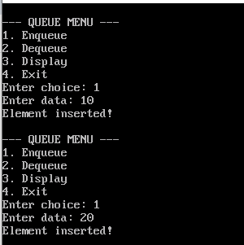
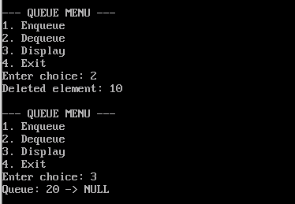
Name: : Vaishnavi Jitendra Salunkhe.
Roll No: 38
Lab Exercise:12

Title: Implementation of priority queue.
#include <stdio.h>

#define MAX 5

// Priority Queue using array
int value[MAX];
int priority[MAX];
int size = 0;

// Insert
void insert() {
int val, pr;

if (size == MAX) {
printf("\nQueue Overflow\n");
return;
}

printf("Enter Value: ");
scanf("%d", &val);

printf("Enter Priority: ");
scanf("%d", &pr);

value[size] = val;
priority[size] = pr;
size++;

printf("Element inserted successfully!\n");
}

// Delete (Highest priority first)
void deleteElement() {
int highest = 0;
int i;

if (size == 0) {
printf("\nQueue Underflow\n");
return;
}

for (i = 1; i < size; i++) {
if (priority[i] > priority[highest]) {
highest = i;
}
}

printf("\nDeleted Element: Value=%d Priority=%d\n",
value[highest], priority[highest]);

// Shift elements
for (i = highest; i < size - 1; i++) {
value[i] = value[i + 1];
priority[i] = priority[i + 1];
}

size--;
}

// Display
void display() {
int i;

if (size == 0) {
printf("\nQueue is empty\n");
return;
}

printf("\nPriority Queue:\n");
for (i = 0; i < size; i++) {
printf("Value=%d Priority=%d\n", value[i], priority[i]);
}
}

// Main function
int main() {
int choice;

do {
printf("\n--- PRIORITY QUEUE MENU ---\n");
printf("1. Insert\n");
printf("2. Delete\n");
printf("3. Display\n");
printf("4. Exit\n");
printf("Enter your choice: ");
scanf("%d", &choice);

switch (choice) {
case 1:
insert();
break;

case 2:
deleteElement();
break;

case 3:
display();
break;

case 4:
printf("Exiting...\n");
break;

default:
printf("Invalid choice!\n");
}

} while (choice != 4);

return 0;
}

Output:
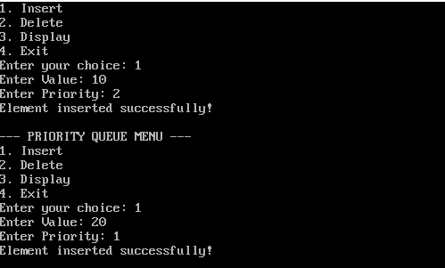
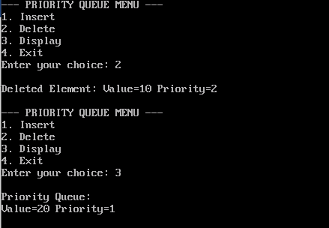

Name:Vaishnavi Jitendra Salunkhe.
Roll No: 38
Lab Exercise:13

Title: Implementation of Dqueue.

#include <stdio.h>
#include <stdlib.h>

#define MAX 5

// Double Ended Queue
int dq[MAX];
int front = -1, rear = -1;

// Insert at Front
void insertFront(int x) {

if ((front == 0 && rear == MAX - 1) || (front == rear + 1)) {
printf("Overflow\n");
return;
}

if (front == -1)
front = rear = 0;

else if (front == 0)
front = MAX - 1;

else
front--;

dq[front] = x;

printf("Inserted at front\n");
}

// Insert at Rear
void insertRear(int x) {

if ((front == 0 && rear == MAX - 1) || (front == rear + 1)) {
printf("Overflow\n");
return;
}

if (rear == -1)
front = rear = 0;

else if (rear == MAX - 1)
rear = 0;

else
rear++;

dq[rear] = x;

printf("Inserted at rear\n");
}

// Delete from Front
void deleteFront() {

if (front == -1) {
printf("Underflow\n");
return;
}

printf("Deleted: %d\n", dq[front]);

if (front == rear)
front = rear = -1;

else if (front == MAX - 1)
front = 0;

else
front++;
}

// Delete from Rear
void deleteRear() {

if (rear == -1) {
printf("Underflow\n");
return;
}

printf("Deleted: %d\n", dq[rear]);

if (front == rear)
front = rear = -1;

else if (rear == 0)
rear = MAX - 1;

else
rear--;
}

// Display
void display() {

int i;

if (front == -1) {
printf("Deque is empty\n");
return;
}

printf("Deque: ");

i = front;

while (1) {
printf("%d ", dq[i]);

if (i == rear)
break;

i = (i + 1) % MAX;
}

printf("\n");
printf("\nFront = %d, Rear = %d\n", front, rear);
}

// Main Menu
int main() {

int choice, value;

while (1) {

printf("\n--- DEQUE MENU ---\n");
printf("1. Insert Front\n");
printf("2. Insert Rear\n");
printf("3. Delete Front\n");
printf("4. Delete Rear\n");
printf("5. Display\n");
printf("6. Exit\n");

printf("Enter choice: ");
scanf("%d", &choice);

switch (choice) {

case 1:
printf("Enter value: ");
scanf("%d", &value);

insertFront(value);
break;

case 2:
printf("Enter value: ");
scanf("%d", &value);

insertRear(value);
break;

case 3:
deleteFront();
break;

case 4:
deleteRear();
break;

case 5:
display();
break;

case 6:
printf("Exiting...\n");
exit(0);

default:
printf("Invalid choice\n");
}
}

return 0;
}

Output:

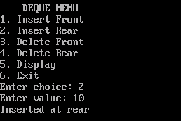
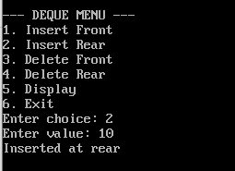
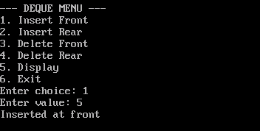
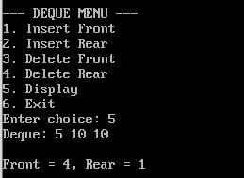

Name:Vaishnavi Jitendra Salunkhe.
Roll No: 38
Lab Exercise:14

Title: Implementation of circular queue.
#include <stdio.h>
#include <conio.h>

#define MAX 5

// Circular Queue using Array
int queue[MAX];
int front = -1, rear = -1;

// Enqueue Operation
void enqueue(int value) {

if ((rear + 1) % MAX == front) {
printf("Queue Overflow\n");
}
else {

// First element
if (front == -1)
front = 0;

rear = (rear + 1) % MAX;
queue[rear] = value;

printf("Inserted: %d\n", value);
}
}

// Dequeue Operation
void dequeue() {

if (front == -1) {
printf("Queue Underflow\n");
}
else {

printf("Deleted: %d\n", queue[front]);

// Queue becomes empty
if (front == rear) {
front = rear = -1;
}
else {
front = (front + 1) % MAX;
}
}
}

// Display Operation
void display() {

if (front == -1) {
printf("Queue is Empty\n");
}
else {

int i = front;

printf("Queue elements: ");

while (1) {

printf("%d ", queue[i]);

if (i == rear)
break;

i = (i + 1) % MAX;
}

printf("\n");
}
}

// Main Function
int main() {

int choice, value;

clrscr();

while (1) {

printf("\n1.Enqueue 2.Dequeue 3.Display 4.Exit\n");
printf("Enter choice: ");
scanf("%d", &choice);

switch (choice) {

case 1:
printf("Enter value: ");
scanf("%d", &value);

enqueue(value);
break;

case 2:
dequeue();
break;

case 3:
display();
break;

case 4:
return 0;

default:
printf("Invalid choice\n");
}
}
}

Output:
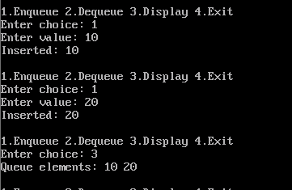

Name: Vaishnavi Jitendra Salunkhe.
Roll No: 38
Lab Exercise:15
Title: Implementation of singly linked list.

#include <stdio.h>
#include <stdlib.h>
// Unit 3: Single linked list
// Node structure
struct node {
int data;
struct node *next;
};

struct node *head = NULL;

// Insert at Beginning
void insert_begin(int value) {
struct node *newnode;
newnode = (struct node*)malloc(sizeof(struct node));

newnode->data = value;
newnode->next = head;
head = newnode;

printf("Inserted at beginning\n");
}

// Insert at End
void insert_end(int value) {
struct node *newnode, *temp;

newnode = (struct node*)malloc(sizeof(struct node));
newnode->data = value;
newnode->next = NULL;

if(head == NULL) {
head = newnode;
} else {
temp = head;
while(temp->next != NULL) {
temp = temp->next;
}
temp->next = newnode;
}

printf("Inserted at end\n");
}

// Delete from Beginning
void delete_begin() {
struct node *temp;

if(head == NULL) {
printf("List is empty\n");
return;
}

temp = head;
head = head->next;
free(temp);

printf("Deleted from beginning\n");
}

// Delete from End
void delete_end() {
struct node *temp, *prev;

if(head == NULL) {
printf("List is empty\n");
return;
}

// Only one node
if(head->next == NULL) {
free(head);
head = NULL;
printf("Deleted last node\n");
return;
}

temp = head;

// Traverse to last node
while(temp->next != NULL) {
prev = temp;
temp = temp->next;
}

prev->next = NULL;
free(temp);

printf("Deleted from end\n");
}

// Display (Traversal)
void display() {
struct node *temp = head;

if(temp == NULL) {
printf("List is empty\n");
return;
}

printf("Linked List: ");
while(temp != NULL) {
printf("%d -> ", temp->data);
temp = temp->next;
}
printf("NULL\n");
}

// Main (Menu Driven)
int main() {
int choice, value;

while(1) {
printf("\n--- Single Linked List Menu ---\n");
printf("1. Insert at Beginning\n");
printf("2. Insert at End\n");
printf("3. Delete from Beginning\n");
printf("4. Delete from End\n");
printf("5. Display\n");
printf("6. Exit\n");

printf("Enter your choice: ");
scanf("%d", &choice);

switch(choice) {
case 1:
printf("Enter value: ");
scanf("%d", &value);
insert_begin(value);
break;

case 2:
printf("Enter value: ");
scanf("%d", &value);
insert_end(value);
break;

case 3:
delete_begin();
break;

case 4:
delete_end();
break;

case 5:
display();
break;

case 6:
exit(0);

default:
printf("Invalid choice\n");
}
}

return 0;
}

Output:
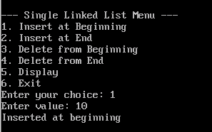
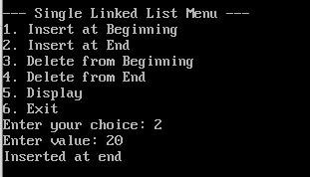
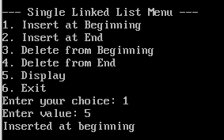
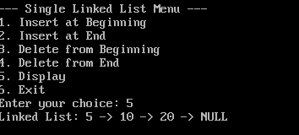

Name:Vaishnavi Jitendra Salunkhe.
Roll No: 38
Lab Exercise:16

Title: Implementation of singly circularly linked list.

#include <stdio.h>
#include <stdlib.h>
// circular single link list
struct node
{
int data;
struct node *next;
};

struct node *head = NULL;

// Insert at beginning
void insert_begin(int value)
{
struct node *newnode, *temp;
newnode = (struct node*)malloc(sizeof(struct node));
newnode->data = value;

if(head == NULL)
{
head = newnode;
newnode->next = head;
}
else
{
temp = head;
while(temp->next != head)
temp = temp->next;

newnode->next = head;
temp->next = newnode;
head = newnode;
}
}

// Insert at end
void insert_end(int value)
{
struct node *newnode, *temp;
newnode = (struct node*)malloc(sizeof(struct node));
newnode->data = value;

if(head == NULL)
{
head = newnode;
newnode->next = head;
}
else
{
temp = head;
while(temp->next != head)
temp = temp->next;

temp->next = newnode;
newnode->next = head;
}
}

// Delete at beginning
void delete_begin()
{
struct node *temp, *last;

if(head == NULL)
{
printf("List is empty\n");
return;
}

if(head->next == head)
{
free(head);
head = NULL;
}
else
{
temp = head;
last = head;

while(last->next != head)
last = last->next;

head = head->next;
last->next = head;
free(temp);
}
}

// Delete at end
void delete_end()
{
struct node *temp, *prev;

if(head == NULL)
{
printf("List is empty\n");
return;
}

if(head->next == head)
{
free(head);
head = NULL;
}
else
{
temp = head;

while(temp->next != head)
{
prev = temp;
temp = temp->next;
}

prev->next = head;
free(temp);
}
}

// Display list
void display()
{
struct node *temp;

if(head == NULL)
{
printf("List is empty\n");
return;
}

temp = head;
do
{
printf("%d -> ", temp->data);
temp = temp->next;
} while(temp != head);

printf("(head)\n");
}

// Main Menu
int main()
{
int choice, value;

while(1)
{
printf("\n1.Insert Begin\n2.Insert End\n3.Delete Begin\n4.Delete End\n5.Display\n6.Exit\n");
printf("Enter choice: ");
scanf("%d", &choice);

switch(choice)
{
case 1:
printf("Enter value: ");
scanf("%d", &value);
insert_begin(value);
break;

case 2:
printf("Enter value: ");
scanf("%d", &value);
insert_end(value);
break;

case 3:
delete_begin();
break;

case 4:
delete_end();
break;

case 5:
display();
break;

case 6:
exit(0);

default:
printf("Invalid choice\n");
}
}
}

Output:
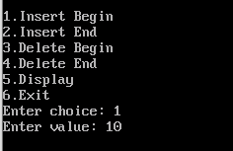

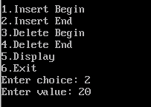
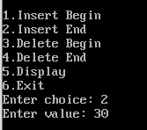
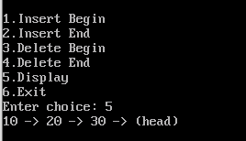

Name: Vaishnavi Jitendra Salunkhe.
Roll No: 38
Lab Exercise:17

Title: Implementation of doubly linked list.
#include <stdio.h>
#include <stdlib.h>
//doubly linked list
struct node {
int data;
struct node *prev;
struct node *next;
};

struct node *head = NULL;

// Insert at Beginning
void insert_begin() {
struct node *newnode;

newnode = (struct node*)malloc(sizeof(struct node));
printf("Enter data: ");
scanf("%d", &newnode->data);

newnode->prev = NULL;
newnode->next = head;

if(head != NULL) {
head->prev = newnode;
}

head = newnode;

printf("Inserted at beginning!\n");
}

// Insert at End
void insert_end() {
struct node *newnode, *temp;

newnode = (struct node*)malloc(sizeof(struct node));
printf("Enter data: ");
scanf("%d", &newnode->data);

newnode->next = NULL;

if(head == NULL) {
newnode->prev = NULL;
head = newnode;
} else {
temp = head;
while(temp->next != NULL) {
temp = temp->next;
}

temp->next = newnode;
newnode->prev = temp;
}

printf("Inserted at end!\n");
}

// Delete from Beginning
void delete_begin() {
struct node *temp;

if(head == NULL) {
printf("List is empty!\n");
} else {
temp = head;
head = head->next;

if(head != NULL) {
head->prev = NULL;
}

free(temp);
printf("Deleted from beginning!\n");
}
}

// Delete from End
void delete_end() {
struct node *temp;

if(head == NULL) {
printf("List is empty!\n");
} else {
temp = head;

// If only one node
if(temp->next == NULL) {
head = NULL;
free(temp);
} else {
while(temp->next != NULL) {
temp = temp->next;
}

temp->prev->next = NULL;
free(temp);
}

printf("Deleted from end!\n");
}
}

// Display
void display() {
struct node *temp;

if(head == NULL) {
printf("List is empty!\n");
} else {
temp = head;
printf("Doubly Linked List: ");
while(temp != NULL) {
printf("%d <-> ", temp->data);
temp = temp->next;
}
printf("NULL\n");
}
}

//
Main Menu
int main() {
int choice;

do {
printf("\n--- DOUBLY LINKED LIST MENU ---\n");
printf("1. Insert at Beginning\n");
printf("2. Insert at End\n");
printf("3. Delete from Beginning\n");
printf("4. Delete from End\n");
printf("5. Display\n");
printf("6. Exit\n");

printf("Enter choice: ");
scanf("%d", &choice);

switch(choice) {
case 1:
insert_begin();
break;

case 2:
insert_end();
break;

case 3:
delete_begin();
break;

case 4:
delete_end();
break;

case 5:
display();
break;

case 6:
printf("Exit...\n");
break;

default:
printf("Invalid choice!\n");
}

} while(choice != 6);
return 0;
}

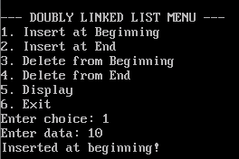
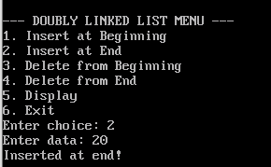
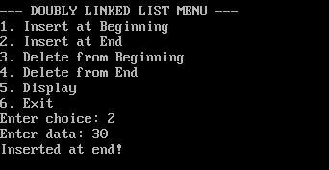
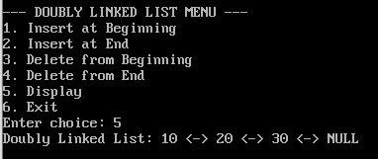

Name: Vaishnavi Jitendra Salunkhe.
Roll No: 38
Lab Exercise:18
Title: Implementation doubly circularly linked list.
#include <stdio.h>
#include <stdlib.h>
// circular Double Link list
struct node {
int data;
struct node *prev;
struct node *next;
};

struct node *head = NULL;

// Insert at Beginning
void insert_begin() {
struct node *newnode, *last;

newnode = (struct node*)malloc(sizeof(struct node));
printf("Enter data: ");
scanf("%d", &newnode->data);

if(head == NULL) {
newnode->next = newnode;
newnode->prev = newnode;
head = newnode;
} else {
last = head->prev;

newnode->next = head;
newnode->prev = last;
last->next = newnode;
head->prev = newnode;

head = newnode;
}

printf("Inserted at beginning!\n");
}

// Insert at End
void insert_end() {
struct node *newnode, *last;

newnode = (struct node*)malloc(sizeof(struct node));
printf("Enter data: ");
scanf("%d", &newnode->data);

if(head == NULL) {
newnode->next = newnode;
newnode->prev = newnode;
head = newnode;
} else {
last = head->prev;

newnode->next = head;
newnode->prev = last;
last->next = newnode;
head->prev = newnode;
}

printf("Inserted at end!\n");
}

// Delete from Beginning
void delete_begin() {
struct node *temp, *last;

if(head == NULL) {
printf("List is empty!\n");
} else if(head->next == head) {
free(head);
head = NULL;
} else {
last = head->prev;
temp = head;

head = head->next;
head->prev = last;
last->next = head;

free(temp);
}

printf("Deleted from beginning!\n");
}
// Delete from End
void delete_end() {
struct node *last, *second_last;
if(head == NULL) {
printf("List is empty!\n");
} else if(head->next == head) {
free(head);
head = NULL;
} else {
last = head->prev;
second_last = last->prev;

second_last->next = head;
head->prev = second_last;

free(last);
}

printf("Deleted from end!\n");
}

// Display
void display() {
struct node *temp;

if(head == NULL) {
printf("List is empty!\n");
} else {
temp = head;
printf("Circular Doubly Linked List: ");
do {
printf("%d <-> ", temp->data);
temp = temp->next;
} while(temp != head);

printf("(back to head)\n");
}
}

// Main Menu
int main() {
int choice;

do {
printf("\n--- CDLL MENU ---\n");
printf("1. Insert Begin\n");
printf("2. Insert End\n");
printf("3. Delete Begin\n");
printf("4. Delete End\n");
printf("5. Display\n");
printf("6. Exit\n");

printf("Enter choice: ");
scanf("%d", &choice);

switch(choice) {
case 1: insert_begin(); break;
case 2: insert_end(); break;
case 3: delete_begin(); break;
case 4: delete_end(); break;
case 5: display(); break;
case 6: printf("Exit...\n"); break;
default: printf("Invalid choice!\n");
}

} while(choice != 6);

return 0;
}

Output:

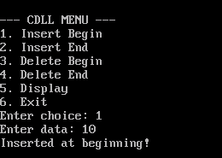
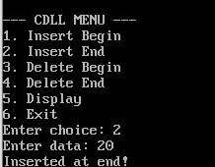
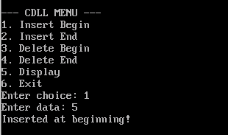
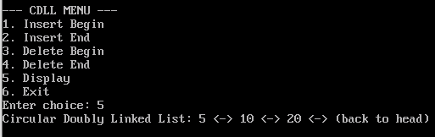

Name:Vaishnavi Jitendra Salunkhe.
Roll No: 38
Lab Exercise:19

Title: Solving polynomial arithmetic using linked list.
#include <stdio.h>
#include <stdlib.h>

struct node {
int coef, exp;
struct node *next;
};

// Create node
struct node* create(int coef, int exp) {
struct node *newnode = (struct node*)malloc(sizeof(struct node));
newnode->coef = coef;
newnode->exp = exp;
newnode->next = NULL;
return newnode;
}

// Insert at end
struct node* insert(struct node *head, int coef, int exp) {
struct node *temp = head, *newnode = create(coef, exp);

if(head == NULL)
return newnode;

while(temp->next != NULL)
temp = temp->next;

temp->next = newnode;
return head;
}

// Polynomial Addition
struct node* add(struct node *p1, struct node *p2) {
struct node *result = NULL;

while(p1 != NULL && p2 != NULL) {
if(p1->exp == p2->exp) {
result = insert(result, p1->coef + p2->coef, p1->exp);
p1 = p1->next;
p2 = p2->next;
}
else if(p1->exp > p2->exp) {
result = insert(result, p1->coef, p1->exp);
p1 = p1->next;
}
else {
result = insert(result, p2->coef, p2->exp);
p2 = p2->next;
}
}

// Remaining terms
while(p1 != NULL) {
result = insert(result, p1->coef, p1->exp);
p1 = p1->next;
}

while(p2 != NULL) {
result = insert(result, p2->coef, p2->exp);
p2 = p2->next;
}

return result;
}

// Display polynomial
void display(struct node *head) {
while(head != NULL) {
printf("%dx^%d", head->coef, head->exp);
head = head->next;
if(head != NULL)
printf(" + ");
}
printf("\n");
}

// Main
int main() {
struct node *p1 = NULL, *p2 = NULL, *result = NULL;

// Polynomial 1: 3x^2 + 2x + 1
p1 = insert(p1, 3, 2);
p1 = insert(p1, 2, 1);
p1 = insert(p1, 1, 0);

// Polynomial 2: 5x^2 + 4
p2 = insert(p2, 5, 2);
p2 = insert(p2, 4, 0);

printf("Polynomial 1: ");
display(p1);

printf("Polynomial 2: ");
display(p2);

result = add(p1, p2);

printf("Result: ");
display(result);

return 0;
}

Output:
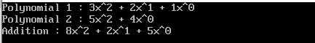

Name: Vaishnavi Jitendra Salunkhe.
Roll No: 38
Lab Exercise:20

Title: Implementation of binary tree and operations.
#include <stdio.h>
#include <stdlib.h>

struct node
{
int data;
struct node *left;
struct node *right;
};

/* Function to create node */
struct node* Create()
{
int x;

printf("Enter data (-1 for no node): ");
scanf("%d", &x);

if(x == -1)
{
return NULL;
}

struct node *newnode;

newnode = (struct node*)malloc(sizeof(struct node));

newnode->data = x;

printf("Enter left child of %d\n", x);
newnode->left = Create();

printf("Enter right child of %d\n", x);
newnode->right = Create();

return newnode;
}

/* Inorder Traversal */
void inorder(struct node *root)
{
if(root != NULL)
{
inorder(root->left);
printf("%d ", root->data);
inorder(root->right);
}
}

/* Preorder Traversal */
void preorder(struct node *root)
{
if(root != NULL)
{
printf("%d ", root->data);
preorder(root->left);
preorder(root->right);
}
}

/* Postorder Traversal */
void postorder(struct node *root)
{
if(root != NULL)
{
postorder(root->left);
postorder(root->right);
printf("%d ", root->data);
}
}

int main()
{
struct node *root = NULL;
int choice;

do
{
printf("\nBinary Tree Menu\n");
printf("1. Create Tree\n");
printf("2. Inorder Traversal\n");
printf("3. Preorder Traversal\n");
printf("4. Postorder Traversal\n");
printf("5. Exit\n");

printf("Enter your choice: ");
scanf("%d", &choice);

switch(choice)
{
case 1:
root = Create();
break;

case 2:
printf("Inorder Traversal: ");
inorder(root);
printf("\n");
break;

case 3:
printf("Preorder Traversal: ");
preorder(root);
printf("\n");
break;

case 4:
printf("Postorder Traversal: ");
postorder(root);
printf("\n");
break;

case 5:
printf("Exiting...\n");
break;

default:
printf("Invalid Choice\n");
}

} while(choice != 5);

return 0;
}

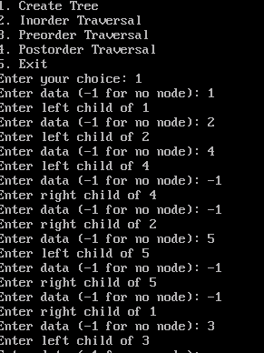
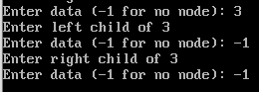
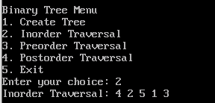

Name:Vaishnavi Jitendra Salunkhe.
Roll No: 38
Lab Exercise:-21
21. Traversal of binary tree.
#include<stdio.h>
#include<stdlib.h>
#include<conio.h>

// Structure of node
struct node
{
int data;
struct node *left;
struct node *right;
};

// Create new node
struct node* createNode(int value)
{
struct node *newnode;

newnode = (struct node*)malloc(sizeof(struct node));

newnode->data = value;
newnode->left = NULL;
newnode->right = NULL;

return newnode;
}

// Insert node
struct node* insert(struct node *root, int value)
{
if(root == NULL)
{
return createNode(value);
}

if(value < root->data)
{
root->left = insert(root->left, value);
}
else if(value > root->data)
{
root->right = insert(root->right, value);
}

return root;
}

// Inorder Traversal
void inorder(struct node *root)
{
if(root != NULL)
{
inorder(root->left);
printf("%d ", root->data);
inorder(root->right);
}
}

// Preorder Traversal
void preorder(struct node *root)
{
if(root != NULL)
{
printf("%d ", root->data);
preorder(root->left);
preorder(root->right);
}
}

// Postorder Traversal
void postorder(struct node *root)
{
if(root != NULL)
{
postorder(root->left);
postorder(root->right);
printf("%d ", root->data);
}
}

// Search in BST
struct node* search(struct node *root, int key)
{
if(root == NULL || root->data == key)
{
return root;
}

if(key < root->data)
{
return search(root->left, key);
}
else
{
return search(root->right, key);
}
}

// Main function
void main()
{
struct node *root = NULL;
struct node *result;

int choice, value;

clrscr();

do
{
printf("\n===== BINARY SEARCH TREE =====\n");
printf("1. Insert\n");
printf("2. Inorder Traversal\n");
printf("3. Preorder Traversal\n");
printf("4. Postorder Traversal\n");
printf("5. Search\n");
printf("6. Exit\n");

printf("Enter your choice: ");
scanf("%d", &choice);

switch(choice)
{
case 1:

printf("Enter value: ");
scanf("%d", &value);

root = insert(root, value);

break;

case 2:

printf("Inorder Traversal: ");
inorder(root);

break;

case 3:

printf("Preorder Traversal: ");
preorder(root);

break;

case 4:

printf("Postorder Traversal: ");
postorder(root);

break;

case 5:

printf("Enter value to search: ");
scanf("%d", &value);

result = search(root, value);

if(result != NULL)
{
printf("Element Found");
}
else
{
printf("Element Not Found");
}

break;

case 6:

printf("Exiting Program...");

break;

default:

printf("Invalid Choice");
}

} while(choice != 6);

getch();
}
Output:

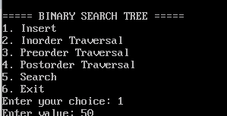
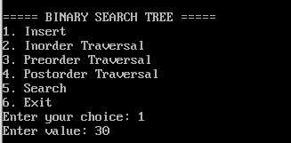
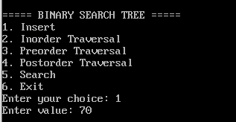
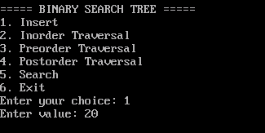

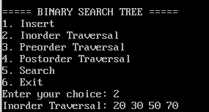

Name:Vaishnavi Jitendra Salunkhe.
Roll No: 38
Lab Exercise:-22

22. Implementation of hash table.
#include<stdio.h>
#define size 10
int hashTable[size];
void init(){
int i;
for(i=0;i<size;i++){
hashTable[i]=-1;
}
}
int hashFunction(int key){
return key%size;
}
void insert(int key){
int index=hashFunction(key);
if(hashTable[index]==-1){
hashTable[index]=key;
}else{
printf("Collison occured for key %d at index %d \n",key,index);
}
}
void display(){
int i;
printf("\n Hash table:\n");
for(i=0;i<size;i++){
if(hashTale[i]!=-1)
printf("Index %d: %d\n",i,hashTable[i]);
else
printf("Index %d:Empty\n",i);
}
}
int main()
{
clear();
intit();
insert(23);
insert(43);
insert(13);
display();
getch();
}
Output:
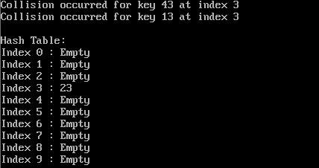

Name:Vaishnavi Jitendra Salunkhe.
Roll No: 38
Lab Exercise:-23
23. Implementation of hash collision resolution techniques.

1. Separate Chaining
#include <stdio.h>
#include <stdlib.h>
#include <conio.h> /* For getch() */

// Define size of hash table
#define SIZE 10

/* Node structure for linked list */
struct Node {
int data;
struct Node* next;
};

/* Hash table array */
struct Node* hashTable[SIZE];

/* Initialize hash table */
void init() {
int i;
for (i = 0; i < SIZE; i++) {
hashTable[i] = NULL;
}
}

/* Hash function */
int hashFunction(int key) {
return key % SIZE;
}

/* Insert key into hash table */
void insert(int key) {
int index = hashFunction(key);
struct Node* newNode = (struct Node*)malloc(sizeof(struct Node));
if (newNode == NULL) {
printf("Memory allocation failed\n");
return;
}
newNode->data = key;
newNode->next = NULL;

/* Insert at beginning of linked list for simplicity */
newNode->next = hashTable[index];
hashTable[index] = newNode;
}

/* Search for a key in hash table */
void search(int key) {
int index = hashFunction(key);
struct Node* temp = hashTable[index];

while (temp != NULL) {
if (temp->data == key) {
printf("Key %d found at index %d\n", key, index);
return;
}
temp = temp->next;
}
printf("Key %d not found\n", key);
}

/* Display entire hash table */
void display() {
int i;
for (i = 0; i < SIZE; i++) {
struct Node* temp = hashTable[i];
printf("Index %d : ", i);
while (temp != NULL) {
printf("%d -> ", temp->data);
temp = temp->next;
}
printf("NULL\n");
}
}

/* Main function */
int main() {
/* Initialize hash table */
init();

/* Insert some keys */
insert(10);
insert(20);
insert(35);
insert(7);
insert(32);

/* Display hash table */
display();

/* Search for keys */
search(15);
search(100);

getch(); /* Wait for key press before exit (optional in TURBO C) */
return 0;
}
Output:

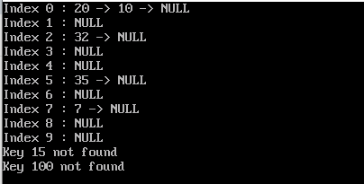
2. Linear Probing
#include <stdio.h>

#define SIZE 10

int hashTable[SIZE];

// Initialize table
void init() {
for (int i = 0; i < SIZE; i++) {
hashTable[i] = -1;
}
}

// Hash function
int hashFunction(int key) {
return key % SIZE;
}

// Insert using linear probing
void insert(int key) {
int index = hashFunction(key);

while (hashTable[index] != -1) {
index = (index + 1) % SIZE;
}

hashTable[index] = key;
}

// Display table
void display() {
printf("\n--- Hash Table ---\n");

for (int i = 0; i < SIZE; i++) {
if (hashTable[i] == -1)
printf("Index %d: EMPTY\n", i);
else
printf("Index %d: %d\n", i, hashTable[i]);
}
}

int main() {

init();

insert(50);
insert(30);
insert(20);
insert(60);

display();

// Keeps console open (IMPORTANT for Windows)
printf("\nPress Enter to exit...");
getchar();

return 0;
}
OutPut:
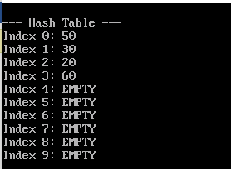

3. Quadratic Probing.
#include <stdio.h>
#include <conio.h>
#define SIZE 10

int hashTable[SIZE];

// Initialize hash table with -1
void init() {
int i;
for(i = 0; i < SIZE; i++)
hashTable[i] = -1;
}

// Hash function: key modulo size
int hashFunction(int key) {
return key % SIZE;
}

// Quadratic probing insert
void insert(int key) {
int index = hashFunction(key);
int i = 0;
int newIndex;

while(i < SIZE) {
newIndex = (index + i * i) % SIZE;
if(hashTable[newIndex] == -1) {
hashTable[newIndex] = key;
return;
}
i++;
}
printf("Hash table is full, cannot insert %d\n", key);
}

// Display the hash table
void display() {
int i;
for(i = 0; i < SIZE; i++) {
printf("Index %d : %d\n", i, hashTable[i]);
}
}

int main() {
clrscr(); // Clear screen
init();

// Insert some keys
insert(50);
insert(30);
insert(20);
insert(60);
insert(25);
insert(35);
insert(45);
insert(55);
insert(65);
insert(75);

printf("Hash Table:\n");
display();

getch(); // Wait for key press
return 0;
}
Output:

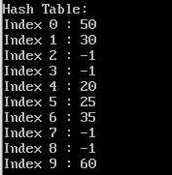

4. Double Hashing.
#include <stdio.h>
#include <conio.h>
#define SIZE 10

int hashTable[SIZE];

// Initialize hash table with -1
void init() {
int i;
for (i = 0; i < SIZE; i++)
hashTable[i] = -1;
}

// First hash function
int h1(int key) {
return key % SIZE;
}

// Second hash function
int h2(int key) {
return 7 - (key % 7);
}

// Insert key using double hashing
void insert(int key) {
int index = h1(key);
int i = 1;

while (hashTable[index] != -1) {
index = (h1(key) + i * h2(key)) % SIZE;
i++;
}

hashTable[index] = key;
}

// Display hash table
void display() {
int i;
for (i = 0; i < SIZE; i++) {
printf("Index %d : %d\n", i, hashTable[i]);
}
}

int main() {
clrscr(); // Clear screen (Turbo C)
init();

insert(50);
insert(30);
insert(20);
insert(60);

display();

getch(); // Wait for key press
return 0;
}
Output:
